MARGERY MANON BRITTAIN (Manon) Record No: 0683

Elder dau of George Clemenger Vincent Brittain (0684) by his wife Marjorie Maude,
nee Swale

Birth: 4 May 1941 at 15 Lower Hatch St, Dublin
Bapt: 1941 at All Saints Church, Blackrock, Co Dublin
Marriage: 15 June 1968 at St Patrick’s Church, Powerscourt to William B. R. B.
Somerville (0682)

Source: Somerville Index

Notes:

Educated: The French School,
Bray, Co Wicklow 1948 - 1957

Col Hume Dudgeon’s Equestrian School

Burton Hall
Stillorgan

Co Dublin 1957 - 1959

Riisby Husmorskole,
Dokka,
Norway 1959

B H S A I 1959

Manon has three sons:
James William Reginald Bellingham (0691) born 22 April 1968
Charles John George Bellingham (0693) born 7 March 1971
Edward Henry Tenison Bellingham (0695) born 19 April 1972

Member Kildare Hunt Club 1961 - …
Life Member Royal Dublin Society

Founded Rossana Arabian Stud 1968
Breeder of pure bred Arabians of pure Crabbet and associated blood lines

Member Arab Horse Society of UK and Ireland

Sometime Council Member

A really keen, able and devoted breeder of the pure bred Arabian Horse. It
has been the greatest sadness that, as a resident of Ireland, where there are
so many sport horses, other than Arabians, which are generally shunned
through ignorance, she has not had access to good stallions or to Breed
Shows. Where she has had mares covered in England, or been lent stallions by
English friends, and produced good stock, she has exhibited at the Arab Horse
shows in England with success.

An enthusiastic gardener with a spectacular garden and important and varied
herbaceous borders (up to 100 yards long)

A true polymath with an astonishing variety of interests: cooking and the
domestic arts, textiles, spinning and weaving, period furniture and paintings,
eastern carpets, animal husbandry, wild and woodland birds, canines and
their training, trees and grasses, biographical history etc, etc all supplemented
by avid reading with an ever enquiring mind.

A really wonderful and supportive wife and mother. She has inherited her
father’s loyalty and integrity and her mother’s gentleness and ability to
communicate with all.

Source: WBRBS from personal knowledge

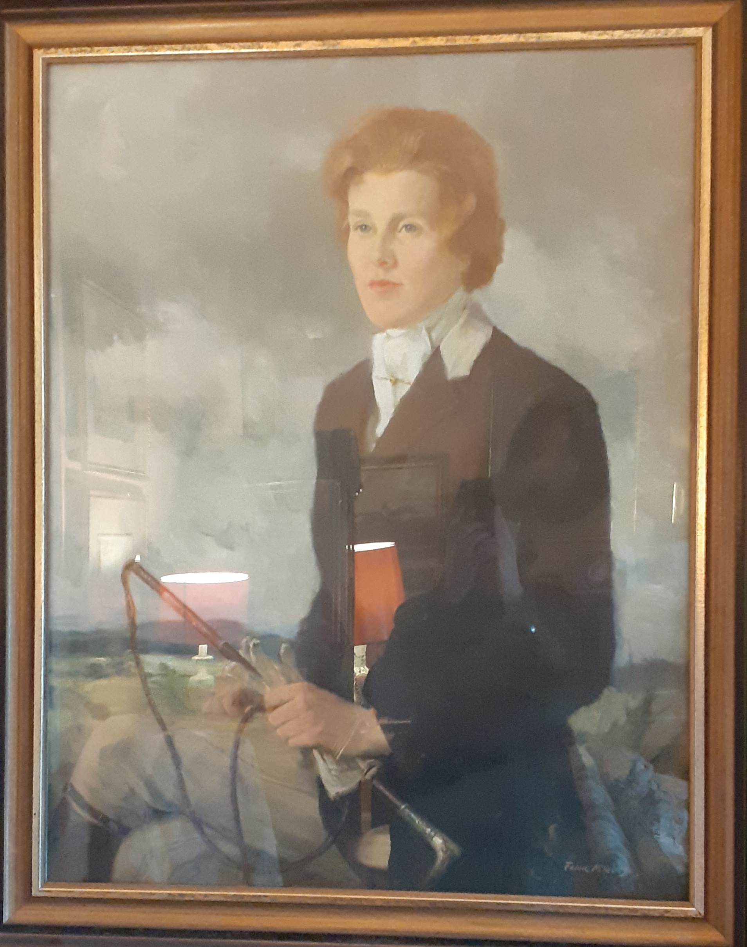
Manon aged 25 in Kildare Hunt dress. (Bad reflection)
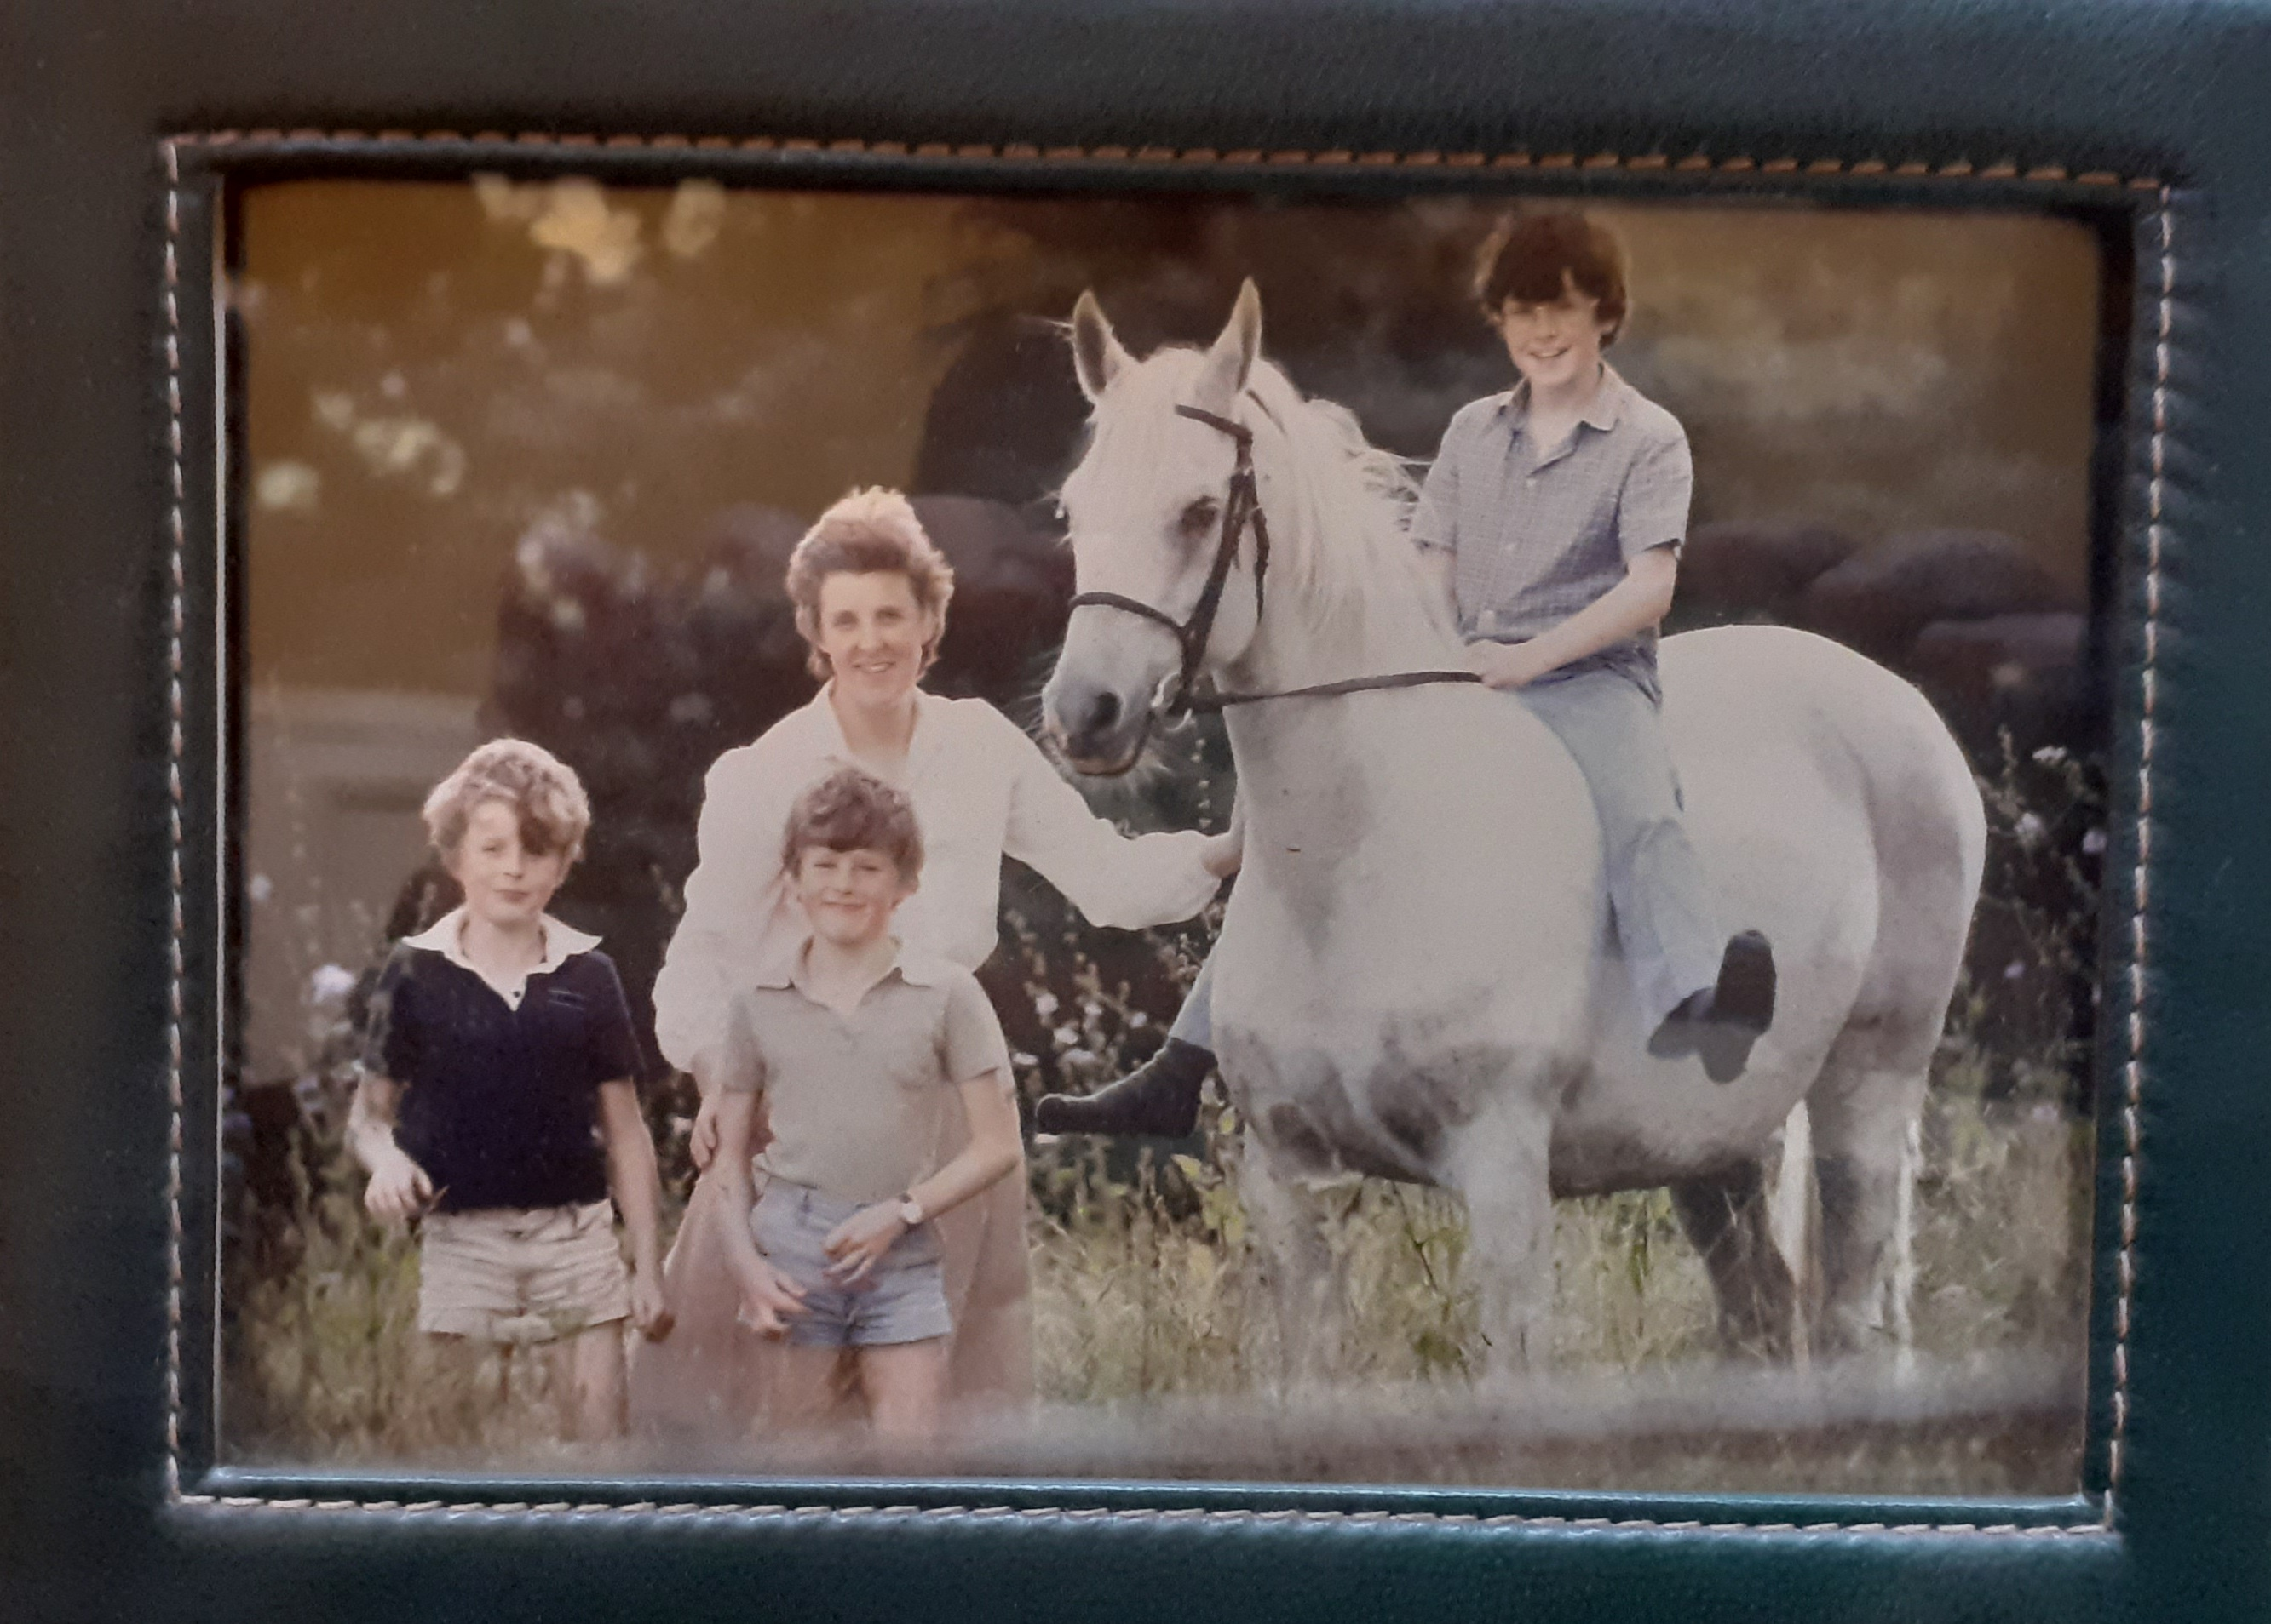

Charles, Manon with Edward in front, Zareef with James in saddle. (Again bad reflection}

